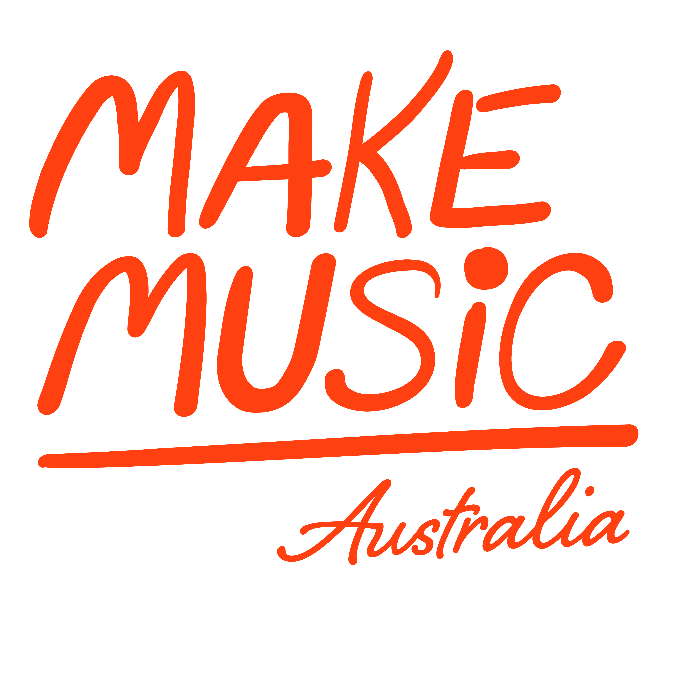Media Release – For Immediate Release

*Date*

Make Music Day is the annual celebration of music making, where everybody can create their own stage and share one of our most cherished social and artistic activities. This year on 21st June, Make Music Day will come to life again across Australia and the rest of the world.

Originating over 40 years ago as a national day of music in France, known as Fete de la Musique, this global phenomenon has people from all walks of life coming together in music making. The Australian Music Association coordinates the campaign in Australia, working with partners around the world on global music making projects.

*Add a paragraph or two about your own event.*

*Add a quote from yourself!*

“Music making is something that resonates with people all over the world, it takes so many different forms and there are many musical languages to share but there really is a musical path for anybody that chooses to follow it,” said Australian Music Association CEO and ARIA Award winning musician Alex Masso. “We have everything from people producing music at home to community bands, orchestras and choirs, street concerts, students, professionals, everyone can get involved.”

Anybody can register an event for Make Music Day, the guiding principles are that events are held on 21st June, they are free to attend, and involve music making of some kind.

See [www.makemusicaustralia.org.au](http://www.makemusicaustralia.org.au/) for more information

***Contact (Your Event)***

*Your name*

*Your email*

*Your phone number*

**Contact (Make Music Day Australia)**

Alex Masso

[alex.masso@australianmusic.asn.au](mailto:alex.masso@australianmusic.asn.au)

0406 361 439